|  |  |
| --- | --- |
| **EX .NO : 11** | **Train detection Automated gate** |
| **DATE :** |

**AIM:**

The aim of the automated train detection gate system is to enhance safety by automatically closing gates when a train approaches and opening them once the train passes.

**PROCEDURE:**

**Step 1:**Connect the microcontroller, Arduino or ESP32to your computer.

**Step 2:**Assign communication ports for interfacing with the sensors.  
**Step 3:**Connect ultrasonic sensors to detect train presence at railway track . **Step 4:**Set up an servo motor for gate open and close.  
**Step 5:**Upload and execute the program to process sensor data. **Step 6:**Observe the result.

**PROGRAM:**

**#include<Servo.h>**

**Servo s2;**

**int trig=4;**

**int echo=3;**

**void setup() {**

**s2.attach(9);**

**pinMode(trig, OUTPUT);**

**pinMode(echo, INPUT);**

**}**

**void loop(){**

**long distance=GetDistance();**

**delay(100);**

**if( distance<=100 ){**

**s2.write(90);**

**delay(1000);**

**}**

**else{**

**s2.write(0);**

**delay(1000);**

**}**

**delay(250);**

**}**

**long GetDistance(){**

**long dur,cm,in;**

**digitalWrite(trig,LOW);**

**delayMicroseconds(2);**

**digitalWrite(trig,HIGH);**

**delayMicroseconds(10);**

**digitalWrite(trig,LOW);**

**dur=pulseIn(echo,HIGH);**

**cm=(dur/2)/29.1;**

**in=cm/2.54;**

**return in;**

**}**

**Components Required :**

• Arduino UNO or ESP32

• Ultrasonic sensors (one per each gate)

• Servo motor

• Resistors and breadboard

• Jumper wires

• Power supply

**OUTPUT:**

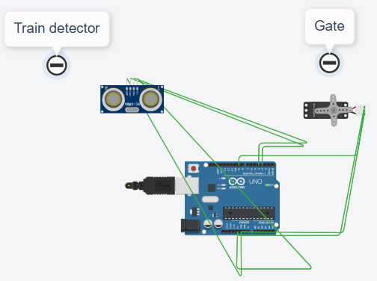

**ESP32 Pin / Arduino pin**

* **D04** - Ultrasonic Sensor Echo Pin
* **D05** - Ultrasonic Sensor Trigger Pin
* **D12** – servo motor (RS Pin)
* **D13** – servo motor (EN Pin)
* **D15** - **GND** - GND
* **5V** - servo motor

|  |  |  |
| --- | --- | --- |
| **MARK ALLOCATION** | | |
| Preparation and conduct of experiments | (50) |  |
| Observation & result | (30) |  |
| Record | (10) |  |
| Viva-voce | (10) |  |
| Total | (100) |  |

**Result:**

The result of the automated train detection gate system is a fully functional gate that responds to train presence by closing when a train is detected and reopening once it has passed and output was verified successfully